# Supporting information of the MS

Modeling Fuzzy Fidelity: Using Microsimulation to Explore Age, Period, and Cohort Effects in Secularization

# AUTHORS

Ivan Puga-Gonzalez (1), David Voas (2), Lukasz Kiszkiel (3), Rachel J. Bacon (4), Wesley J. Wildman (4,5,6), F. LeRon Shults (1,6), Konrad Talmont-Kaminski (3)

# AFFILIATIONS

1. Center for Modeling Social Systems (CMSS) at NORCE, Kristiansand, Norway

2. UCL Social Research Institute, University College London

3. Society and Cognition Unit, University of Bialystok, Poland

4. Center for Mind and Culture (CMAC), Boston, United States

5. Faculty of Computing and Data Sciences, Boston University

6. Institute for Global Development and Planning, University of Agder

Table S1

Average religiosity values at the population level per country, number of respondents (n), and wave of the European Social Survey. Religiosity values range between [21-3], see main text for a description on how these values were calculated.

|  |  |  |  |  |  |  |  |  |  |
| --- | --- | --- | --- | --- | --- | --- | --- | --- | --- |
| **Country** | **Wave 1** | **Wave 2** | **Wave 3** | **Wave 4** | **Wave 5** | **Wave 6** | **Wave 7** | **Wave 8** | **Wave 9** |
| BE Belgium | 9.57  (n=1824) | 9.27  (n=1778) | 9.51  (n=1798) | 9.42  (n=1760) | 8.86  (n=1704) | 8.66  (n=1869) | 8.71  (n=1769) | 9.24  (n=1766) | 8.94  (n=1766) |
| CH Switzerland | 10.86  (n=2037) | 11.47  (n=2141) | 11.17  (n=1803) | 10.73  (n=1819) | 10.59  (n=1502) | 10.35  (n=1493) | 10.31  (n=1531) | 9.91  (n=1519) | 9.86  (n=1526) |
| DE Germany | 9.16  (n=2895) | 9.24  (n=2805) | 9.21  (n=2868) | 9.60  (n=2725) | 9.21  (n=3026) | 9.78  (n=2951) | 9.34  (n=3031) | 9.53  (n=2849) | 8.79  (n=2354) |
| ES Spain | 10.03  (n=1709) | 10.23  (n=1642) | 10.48  (n=1875) | 10.26  (n=2571) | 10.50  (n=1880) | 10.21  (n=1888) | 9.80  (n=1925) | 10.13  (n=1958) | 9.33  (n=1667) |
| FI Finland | 10.52  (n=2000) | 10.47  (n=2022) | 10.15  (n=1896) | 10.30  (n=2195) | 10.31  (n=1878) | 9.83  (n=2197) | 9.70  (n=2087) | 10.18  (n=1925) | 9.51  (n=1755) |
| FR France | 8.19  (n=1503) | 8.16  (n=1806) | 8.19  (n=1986) | 8.10  (n=2073) | 8.24  (n=1728) | 8.43  (n=1968) | 8.52  (n=1913) | 8.43  (n=2069) | 8.69  (n=2010) |
| GB United Kingdom | 8.92  (n=2048) | 9.49  (n=1891) | 8.88  (n=2387) | 9.04  (n=2325) | 8.69  (n=2415) | 9.22  (n=2270) | 8.64  (n=2246) | 8.76  (n=1923) | 8.51  (n=2190) |
| HU Hungary | 9.61  (n=1685) | 8.98  (n=1495) | 9.47  (n=1511) | 9.86  (n=1544) | 9.64  (n=1561) | 9.00  (n=2014) | 9.17  (n=1698) | 8.83  (n=1614) | 8.73  (n=1661) |
| IE Ireland | 14.32  (n=2046) | 14.71  (n=2286) | 13.79  (n=1716) | 14.12  (n=1758) | 13.26  (n=2576) | 13.57  (n=2626) | 13.10  (n=2383) | 12.93  (n=2724) | 12.14  (n=2172) |
| NL Netherlands | 9.76  (n=2364) | 10.05  (n=1879) | 9.60  (n=1889) | 9.77  (n=1778) | 9.28  (n=1829) | 9.15  (n=1845) | 8.95  (n=1917) | 8.50  (n=1681) | 8.42  (n=1665) |
| NO Norway | 8.71  (n=2036) | 8.56  (n=1760) | 8.60  (n=1750) | 8.27  (n=1549) | 8.50  (n=1549) | 8.39  (n=1624) | 8.53  (n=1436) | 8.57  (n=1545) | 7.71  (n=1374) |
| PL Poland | 15.10  (n=2100) | 14.98  (n=1716) | 15.27  (n=1721) | 14.75  (n=1619) | 14.51  (n=1751) | 14.45  (n=1898) | 14.49  (n=1615) | 14.26  (n=1692) | 13.63  (n=1500) |
| PT Portugal | 12.31  (n=1511) | 12.00  (n=2050) | 12.30  (n=2222) | 12.69  (n=2367) | 12.06  (n=2150) | 11.58  (n=2151) | 12.28  (n=1265) | 11.78  (n=1270) | 11.52  (n=1045) |
| SE Sweden | 7.79  (n=1995) | 7.70  (n=1948) | 7.71  (n=1926) | 7.57  (n=1830) | 7.63  (n=1497) | 7.73  (n=1845) | 7.17  (n=1790) | 7.14  (n=1547) | 7.36  (n=1539) |
| SI Slovenia | 10.29  (n=1519) | 10.15  (n=1428) | 9.92  (n=1476) | 10.01  (n=1286) | 9.65  (n=1400) | 9.42  (n=1257) | 9.51  (n=1224) | 9.07  (n=1307) | 9.59  (n=1318) |
| **Average** | **10.34**  (n=**29272**) | **10.36**  (n=**28647**) | **10.28**  (n=**28824**) | **10.30**  (n=**29198**) | **10.06**  (n=**28446**) | **9.98**  (n=**29897**) | **9.85**  (n=**27830**) | **9.80**  (n=**27389**) | **9.51**  (n=**25542**) |

Note that Germany is included in this list. However, excluding Germany from the analysis has next to no effect in the calculation of the linear decay of religiosity, fig S1. Hence, our comparisons between model fit and linear religiosity decay at the population level and overall conclusions remain unchanged.

|  |  |
| --- | --- |
| A) | B) |
|  |  |

Figure S A) Religiosity decay at the population level calculated from the 9 waves of the ESS and all countries in table S1 (blue) and when excluding Germany (red); B) Religiosity decay at the population level extrapolated from a linear regression in (A).

Table S2. Values of the parameters producing the best fit for each of the APC processes when targeting the cohort decay religiosity curve.

|  |  |
| --- | --- |
| **APC process(es)** | **Parameters value** |
| a) Static period effect | Inhibitor: 0.001 |
| b) Static period effect with age effect | Inhibitor: 0.028  Gamma: 77.297 |
| c) Static period effect with double age effect | Inhibitor: 0.056  Gamma inhibitor: 54.188  Inflection age: 53  Enhancer: 0.153  Gamma enhancer: 5.853 |
| d) Dynamic period effect | C: 0.002 |
| e) Dynamic period effect with age effect | C: 0.047  Gama: 100 |
| f) Cohort effect | Alpha: 0.297  Beta: 0.024 |
| g) Cohort effect with age effect | Alpha: 0.891  Beta: 0.098  Enhancer: 0.2  Gamma: 8.924 |
| h) Cohort and proportion of non-religious | C: 0.172  SD: 0.058 |
| i) Cohort and proportion of religious | C: 0.004  SD: 0.34 |
| j) Cohort and proportion of fuzzies | C: 0.187  SD: 0.115 |
| k) Cohort and proportion of seculars | C: 0.221  SD: 0.227 |
| l) Cohort and proportion of religious*seculars | C: 1.34  SD: 0.216 |

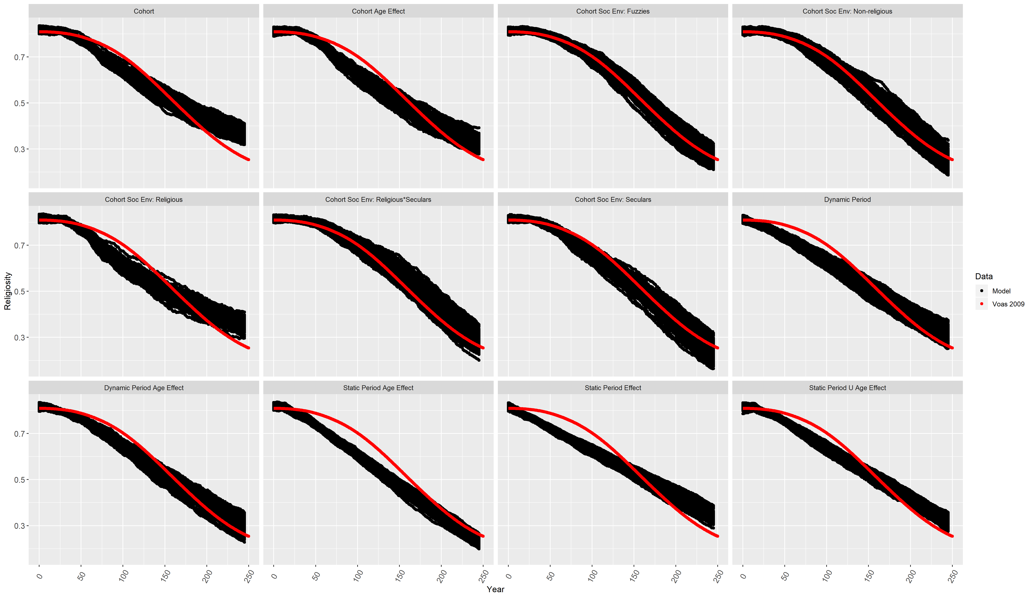

Figure S2 Trajectories of 100 model runs according to each APC process (black) and the s-shape religiosity decay at the population level as the target curve (red).

Figure S3 Trajectories of 100 model runs for the dynamics R-F-S shares according to each APC process (hollow dots) and the projections according to Voas 2009 (filled squares). Values of the model parameters were optimized by targeting the s-shape religiosity decay at the population level. Cat = category.

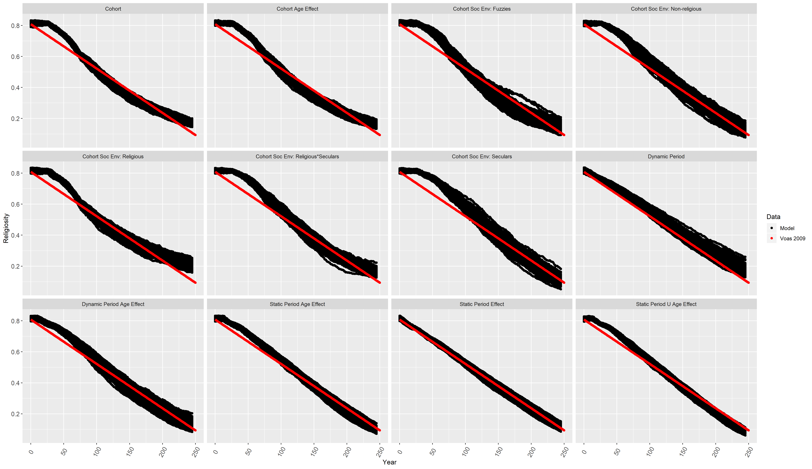

Figure S4 Trajectories of 100 model runs according to each APC process (black) and the linear religiosity decay at the population level as the target curve (red).

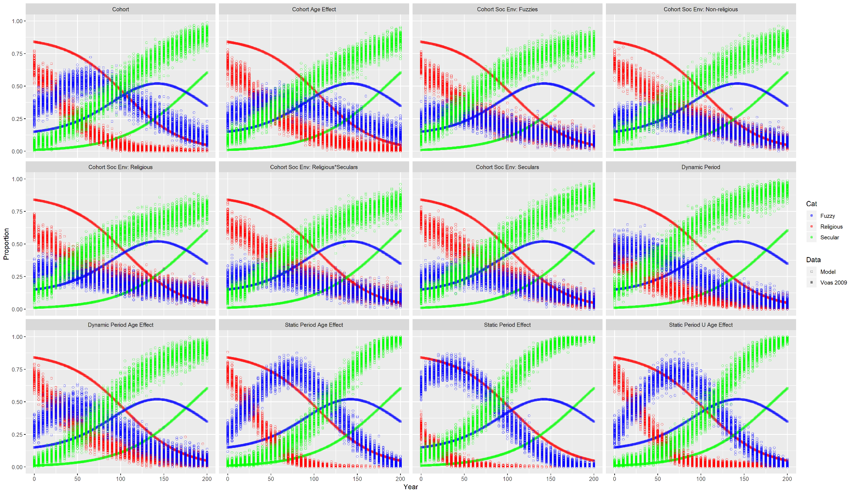

Figure S5 Trajectories of 100 model runs for the dynamics R-F-S shares according to each APC process (hollow dots) and the projections according to Voas 2009 (filled squares). Values of the model parameters were optimized by targeting the linear religiosity decay at the population level. Cat = category.